**Project Description**

**Shadow Dodge: Space Adventure** is a fast-paced arcade game where players control a spaceship dodging falling space debris. Collect power-ups (shields, speed boosts, extra lives) to survive longer and achieve high scores. Features include:

* Dynamic space background with stars and nebulas
* Progressive difficulty system
* Particle effects for explosions
* Power-up system with timed abilities
* High score tracking

**Setup Instructions**

1. **Requirements**:
   * Python 3.6+
   * Pygame library

**Installation**

pip install pygame

**Running the Game**:

python shadow_dodge.py

Controls

Left/Right Arrow Keys: Move spaceship

Any Key: Start game/select menu options

**3. Key Features Showcase**

**Core Mechanics**

| **Feature** | **Implementation Details** |
| --- | --- |
| **Dynamic Difficulty** | Speed and spawn rate increase over time (difficulty = 1 + min(game_time // 30000, 4)) |
| **Collision System** | Pixel-perfect collision between player and debris with shield immunity |
| **Particle Effects** | Explosion particles with fading and physics (create_particles()) |

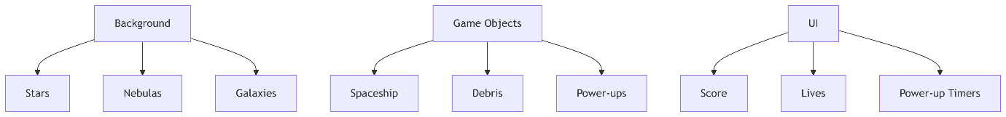

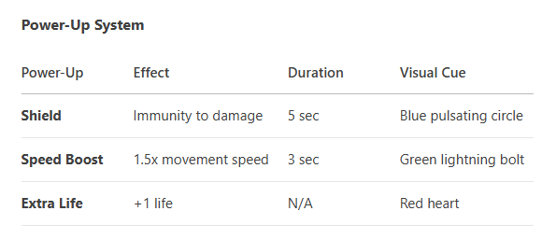

**Performance Metrics**

* Consistent 60 FPS via clock.tick(60)
* Object pooling for debris and particles
* Efficient rendering with pygame.SRCALPHA surfaces